Rack mounting

The PT 5201 is delivered with the following mounting parts:
1 pc. Side bracket
1 pc Blindplate incl. rack mount ears
2 pc. Suppor base plates
4 pc Pan head screws M3x(
9 pc. Countersink screws M3x6
4 pc. Pan head screw M6x16 for rack frame
4 pc. Rack frame clips/nuts M6
4 pc. Rubber feet (for table top use )
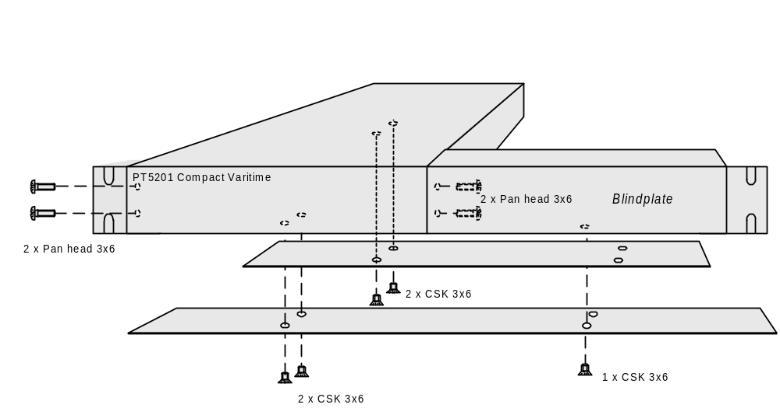
Single PT 5201 with blind plate
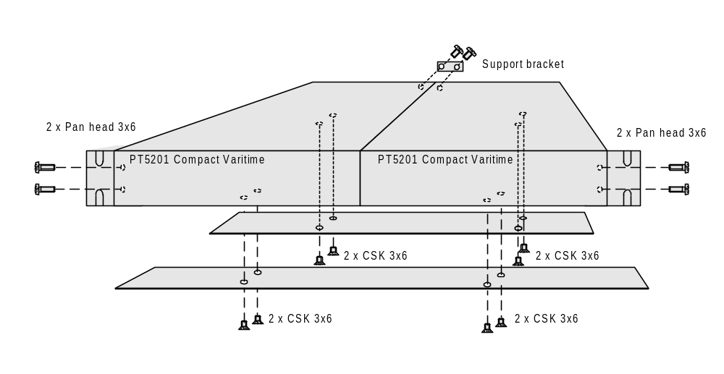
Double set of PT 5201

